

**ARTIFICIAL INTELLIGENCE PROJECT**

**REPORT FILE**

**TITLE: - Production System of 15 puzzle problem**

**SECTION: -K18BY GROUP: - 01**

**SUBMITTED TO: - ISHATPREET KAUR**

**SUBMITTED BY**

**SUBMITTED BY:**

* **Anil singh 11803558 22**
* **Bhupesh parakh 11803483 24**

**Nomaan barkat 11803300 23**

**Murti 11802914 21**

**Abstract**

The 15-puzzle is a well-known game which has a long history stretching back in the 1870’s. The goal of the game is to arrange a shuffled set of 15 numbered tiles in ascending order, by sliding tiles into the one vacant space on a 4 *×* 4 grid. In this paper, we study how Reinforcement Learning can be employed to solve the 15-puzzle problem. Mathematically, this problem can be described as a Markov Decision Process with the states being puzzle confifigurations. This leads to a large state space with approximately 10^13 elements. In order to deal with this large state space, we present a local variation of the Value-Iteration approach appropriate to solve the 15-puzzle starting from arbitrary confifigurations.The feasibility of the approach and the plausibility of the analysis are additionally shown by simulation results.

**Acknowledgment**

I would like to express my profound grateful to prof ISHATPREET KAUR ma’am or providing an opportunity to complete my academics .I would like to show my greatest appreciation to my teacher Ishatpreet kaur to support for the completion of project.I can’t say thank you enough for the tremendous support and help of the all the members. The guidance and support received from all the members who contributed and who are contributing to this report, was vital for the success of the project. I am grateful for their constant support and help. The project on 15 puzzle problem for using Knowledgeable Database was very helpful to us in giving the necessary background information and inspiration in choosing this topic for the project.

**CONTENTS**

**1.INTRODUCTION**

1.1 Project Idea

**2.PROBLEM DEFINITION AND SCOPE**

2.1 Problem Statement.

2.2 Goals and objectives.

**3. DESIGN FRAME WORK**

3.1Area of Project.

**4.OBJECIVES AND OUTCOMES**

**5.APPLICATIONS**

**6.PROJECT DESIGN**

6.1 Data flow diagram

**7.CONCLUSION**

7.1 Conclusion .

1. **INTRODUCTION:-**

The 15-puzzle (also called Gem Puzzle, Boss Puzzle, Game of Fifteen, Mystic Square and many others) is a [sliding puzzle](https://en.wikipedia.org/wiki/Sliding_puzzle) that consists of a frame of numbered square tiles in random order with one tile missing. The puzzle also exists in other sizes, particularly the smaller 8-puzzle. If the size is 3×3 tiles, the puzzle is called the 8-puzzle or 9-puzzle, and if 4×4 tiles, the puzzle is called the 15-puzzle or 16-puzzle named, respectively, for the number of tiles and the number of spaces. The object of the puzzle is to place the tiles in order by making sliding moves that use the empty space.

The *n*-puzzle is a classical problem for modelling [algorithms](https://en.wikipedia.org/wiki/Algorithm) involving [heuristics](https://en.wikipedia.org/wiki/Heuristic_(computer_science)). Commonly used heuristics for this problem include counting the number of misplaced tiles and finding the sum of the [taxicab distances](https://en.wikipedia.org/wiki/Taxicab_distance) between each block and its position in the goal configuration.

The puzzle was "invented" by Noyes Palmer Chapman, a postmaster in [Canastota, New York](https://en.wikipedia.org/wiki/Canastota,_New_York), who is said to have shown friends, as early as 1874, a precursor puzzle consisting of 16 numbered blocks that were to be put together in rows of four, [each summing to 34](https://en.wikipedia.org/wiki/Magic_square). Copies of the improved Fifteen Puzzle made their way to [Syracuse, New York](https://en.wikipedia.org/wiki/Syracuse,_New_York), by way of Noyes' son, Frank, and from there, via sundry connections, to [Watch Hill, Rhode Island](https://en.wikipedia.org/wiki/Watch_Hill,_Rhode_Island), and finally to [Hartford](https://en.wikipedia.org/wiki/Hartford) (Connecticut), where students in the [American School for the Deaf](https://en.wikipedia.org/wiki/American_School_for_the_Deaf) started manufacturing the puzzle and, by December 1879, selling them both locally and in [Boston](https://en.wikipedia.org/wiki/Boston), Massachusetts. Shown one of these, Matthias Rice, who ran a fancy woodworking business in Boston, started manufacturing the puzzle sometime in December 1879 and convinced a "Yankee Notions" fancy goods dealer to sell them under the name of "Gem Puzzle". In late January 1880, Dr. Charles Pevey, a dentist in [Worcester, Massachusetts](https://en.wikipedia.org/wiki/Worcester,_Massachusetts), garnered some attention by offering a cash reward for a solution to the Fifteen Puzzle.

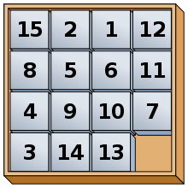

**PROBLEM DEFINITION AND SCOPE**

15 puzzle will have 4 rows and 4 columns and an8 puzzle will have 3 rows and 3 columns. The puzzleConsists of N tiles and One Empty space where the tiles can moved Goal configuration of the Puzzle are provided.(also called Gem Puzzle,Boss puzzle,Game of fifteen,Mystic Square and many other.)

Implemented BFS algorithym(Breadth first search).

The 15 Puzzle is a sliding puzzle that consists of frame numbered square tiles in a random order with one tile missing.

The puzzle also exists in other sizes,Particularly that small 8 puzzle or 9 puzzle,and if 4×4 tiles, The puzzle is also called the 15 Puzzle or 16 Puzzle named respectively for the number of tiles amd number of spaces.

The object of the puzzle is to place the tiles in order by making sliding moves that use the empty space.

**The 15 Puzzle ALGORITHM**

solve = (startGrid) ->

frontier = new PriorityQueue

frontier.enqueue(new SolverState(startGrid, []))

while not frontier.empty()

curState = frontier.dequeue()

if curState.solved

return curState.steps

candidateMoves = grid.validMoves()

for move in candidateMoves

nextGrid = grid.applyMove(move)

nextSteps = curState.steps.concat([move])

nextState = new SolverState(nextGrid, nextSteps)

frontier.enqueue(nextState)

**Goals and objectives**

The 15-puzzle is a sliding puzzle that consists of a frame of numbered square tiles in random order with one tile missing. The puzzle also exists in other sizes, particularly the smaller 8-puzzle. If the size is 3x3 tiles, the puzzle is called the 8-puzzle or 9-puzzle, and if 4x4 tiles, the puzzle is called the 15-puzzle or 16-puzzle named, respectively, for the number of tiles and the number of spaces.

The object of the puzzle is to place the tiles in order by making sliding moves that use the empty space. The n-puzzle is a classical problem for modelling algorithms involving heuristics.

The objective of this game is a good for exercise of user’s brain. Each time when the user play this game he face a new random number of puzzle or a new shuffle puzzle so this make interest of user in to this game.

**Data flow Digram(DFD)**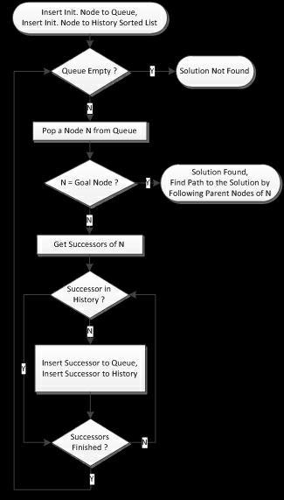

**Design Frame Work**

In this section we present the “COMPUTATIONAL PUZZLE DESIGN” (CPD) frame work.It consists of three aspects.The first aspects are the three components of cps. Formulating the problem,Bulding an alogorithmic solution,Testing and debugging

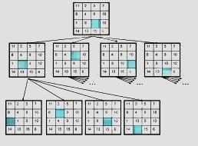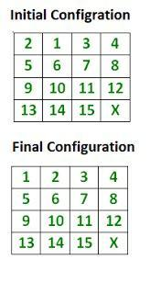

The second aspect involves what the players have to do.This aspects lists specific activities that will have to be designed for in order to accomplish the CPS learning objectives of each component.

The third and final aspect are the Gameplay element.The Frame work have three gameplay elements.Core mechanics,challenges and goals to What players have to do.

And thus indirectly to the three cps components.To assist in thinking how to design three gameplay elements in the context of cps.

To assist in thinking the gameplay elements how to design in the context of cps the frame work offers a number of design principles.

Before we detail the framework through the mappings of cps component with the gameplay elements,we will first explain our rationale for the three gameplay elements and how they relate to CPS components.

By mechanics we refer to main method of play describe with verbs to define what players do in the gameplay world.The mechanics for CT teaching games involve solving problems competationally,andmaincore mechanic is formulating the problem.The problem also works correctly for non standard number of rows and columns.

Based on gameplay rules defined byFrasca,Djaouti el at.identified two types of game rule.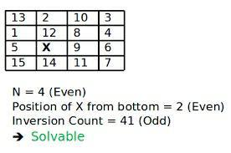

**Conclusion**

In this study, we investigate the possibility of using RL to solve the popular

15-puzzle game. Due to the high state space dimension of the problem, it is

diffiffifficult to straightforwardly employ state-of-the-art RL algorithms. In order to

deal with this large state space, we proposed a local variation of the well-known

Value-Iteration appropriate to solve the 15-puzzle problem. Our algorithm is in

spired by the insight that humans use to solve the 15-puzzle game locally, by

sequentially moving tiles to their correct positions. Furthermore, we provide a

theoretical analysis showing the feasibility of the proposed approach. The plau

sibility of the analysis is supported by several simulation results.